**ASSIGNMENT 4.1**

**on**

**Microservices**

**Submitted by:**

**Haseebullah Shaikh (2303.KHI.DEG.015)**

**and**

**Faiza Gulzar Ahmed (2303.khi.deg.001)**

**Dated:** 5th May 2023

**Task 01: Browse to:**  
**tasks/4_microservices_development/day_1_microservices/docker_composeexample**  
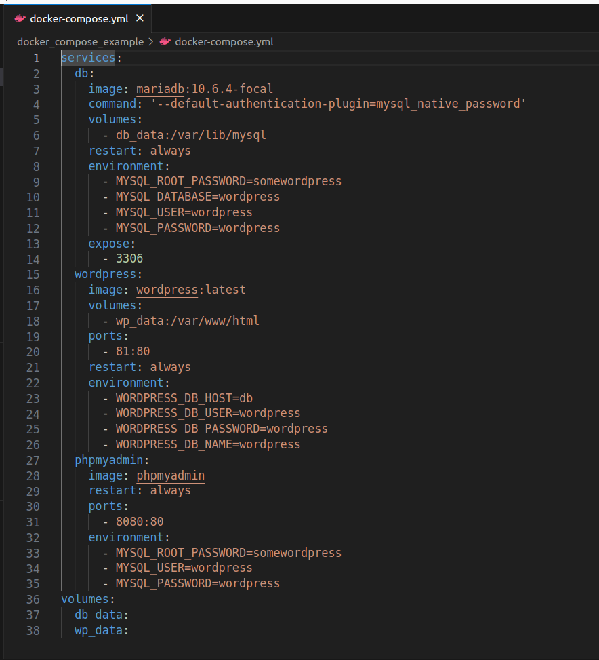

**Next you will:**  
**- Start the system using docker-compose so that it runs in background,**

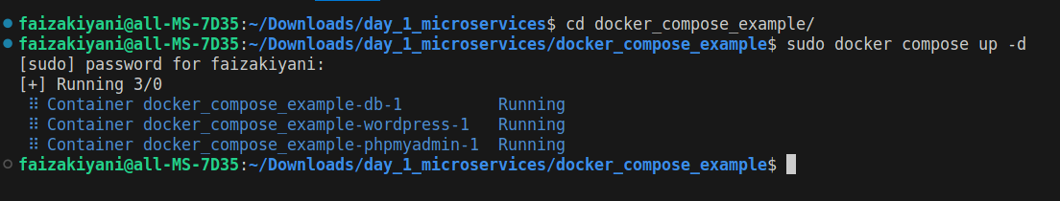

**- Visit http://127.0.0.1/ to see WordPress installation panel,**

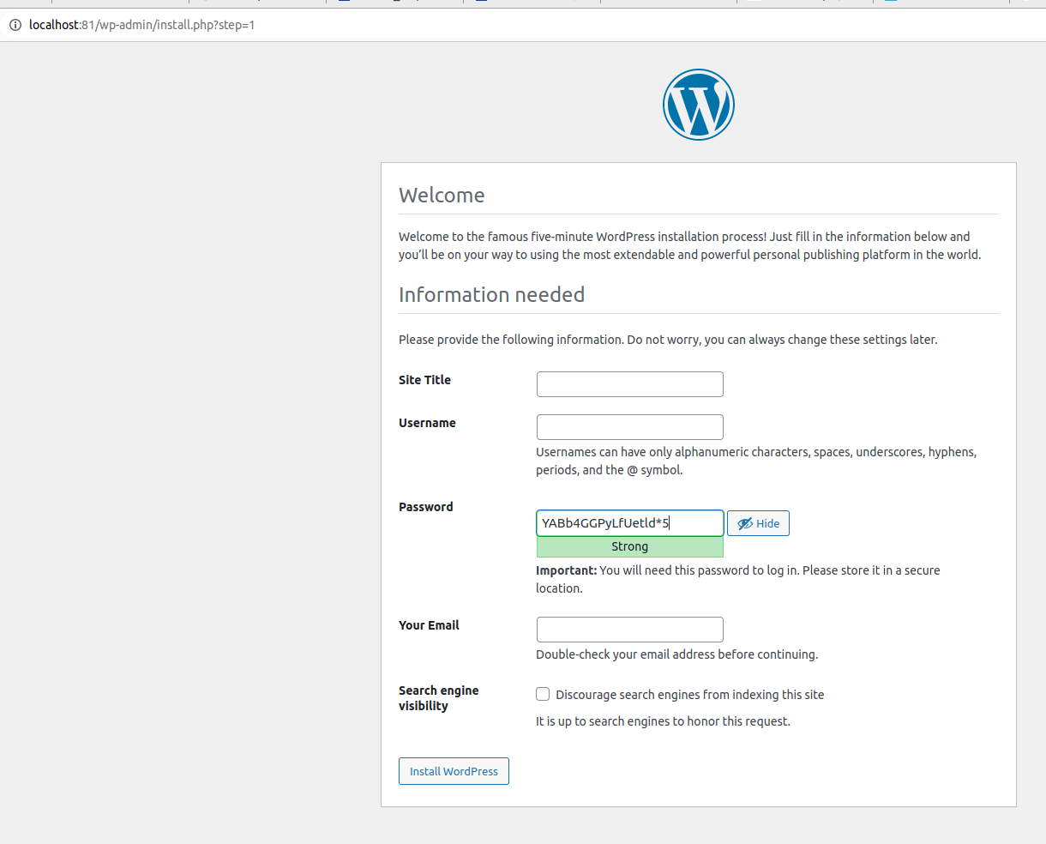

**- See the system logs**

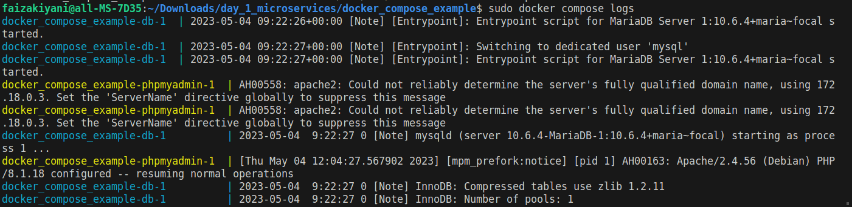

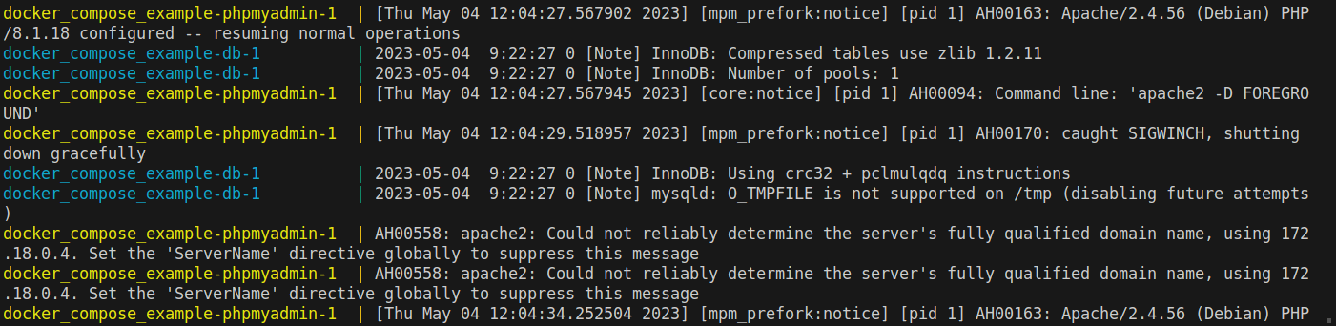

Additional logs are written in file named composed logs.

**- Add a PHPMyAdmin service from**

**https://hub.docker.com/r/phpmyadmin/phpmyadmin/ so that you can manage the raw database contents.**

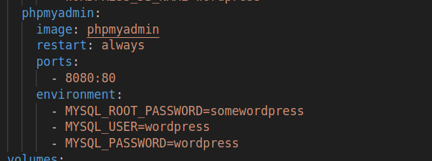

**Verifying services are accessed on ports**

**PhpMyAdmin**

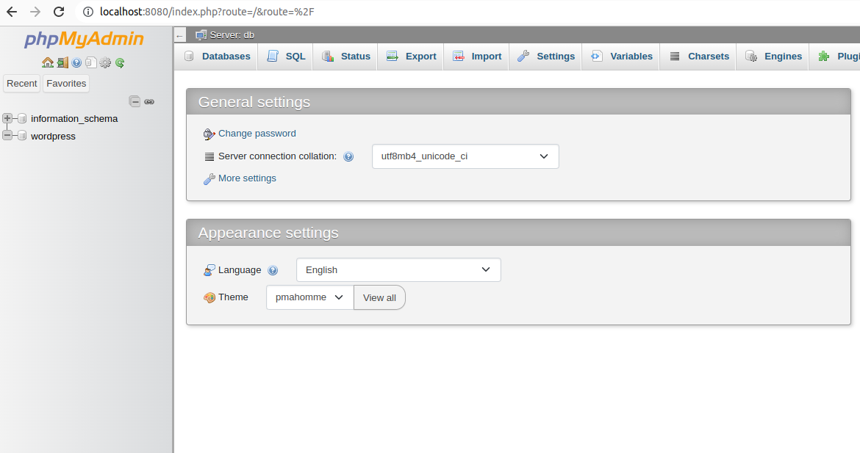

**Wordpress**

